Dayananda Sagar Academy of Technology & Management

Bengaluru – 560082



An Internship Report on

##### “SPARK PLUG MANUFACTURING PROCESS”

**At**



**(09/07/2019-07/08/2019)**

Submitted by:

**NESAR A (1DT16ME037)**

Submitted to:

**Mr. SHAHEED M.S (NhP/HRL3)**

**Submitted on: 07/08/2019**

**ACKNOWLEDGEMENT**

The internship opportunity we had with BOSCH was a great chance for learning and professional development. Therefore, we consider our self very lucky as we were provided with an opportunity to be part of it. We are also grateful for having a chance to meet so many wonderful people and professional who led us through this internship period.

We express our deepest thanks to our mentor **Mr. LOKESH** (**AA-SP/TEF12-IN**) who in spite being busy, took time out to guide and keep us on the correct path and allowing us to carry out our internship at their esteemed organization .

We would also like to extend our gratitude **to Mr. Shaheed (NHP/HRL3)** who has given the opportunity to carry out the internship in their organization for a period of one month and also guiding on various life skills.

We take this opportunity to thank the operators who

supported us and always were available to clarify

all of the queries and provide detailed information about

their respective work.

We take this opportunity as a big milestone in our

career development. We will strive to use the gained skills

and knowledge in the best possible way and we will continue

to work hard and improve myself to attain desired career objectives.

Sincerely,

**Contents:**

1. **Introduction to Bosch 4**

History of Bosch 4

Bosch in India 4

Bosch Naganathapura Bengaluru 5

1. **Spark Plug**

Functions of Spark Plug 6

Parts of Spark Plug 7

1. **Manufacturing of Spark Plug**

Insulator manufacturing process 9

Centre electrode manufacturing 21

Insulator assembly process 22

Housing manufacturing process 28

Spark Plug final assembly process 33

Requirement of Spark plug 38

1. **5sPrinciples 39**
2. **Maintenance engineering 42**
3. **Hydraulics 47**

1. **Conclusion 50**

# Introduction to Bosch

#### HISTORY

The company was set up in Stuttgart in 1886 by Robert Bosch as “Workshop for precision Mechanics and Electrical Engineering.” The special ownership structure of Robert Bosch GmbH guarantees the entrepreneurial freedom of the Bosch Group, making it possible for the company to plan over the long termed to undertake significant up front investments in the safeguarding of its future. Ninety-two percent of the share capital of Robert Bosch GmbH. There maintaining shares are held by the Bosch family and by Robert Bosch GmbH.

The Bosch Group is a leading global supplier of technology and services. It employs roughly 400,500 associates worldwide (as of December31,2017).According to preliminary figures, the company generatedsalesof78billioneurosin2017.Itsoperationsaredivided into four business sectors:

* + Mobility Solutions
  + Industrial Technology
  + Consumer goods
  + Energy and Building Technology

Bosch offers innovative solutions for smart homes, smart cities, connected mobility, and connected manufacturing. It uses its expertise in sensor, software, and services, as well as its own IOT cloud, to offer its customers connected, cross-domain solutions from a single source. The Bosch Group’s strategic objective is to deliver innovations for a connected life. Bosch improves quality of life worldwide with products and services that are innovative and spark enthusiasm. In short, Bosch creates technology that is “**Invented for life**”.

The Bosch Group comprises Robert Bosch GmbH and its roughly 450 subsidiaries and regional companies in some 60 countries. Including sales and service partners, Bosch’s global manufacturing, and sales network covers nearly every country in the world. The basis for the

company's future growth is its innovative strength. At 125 locations across the globe, Bosch employs 62,500 associates in research and Development. Bosch has been present in India for more than 90 years – first through a representative office in Calcutta in 1951 and from 1992 through its subsidiary, Bosch Limited. The Bosch group operates in India through twelve companies, viz, Bosch Limited. Bosch chassis systems India private Limited, Bosch Rexroth India Private limited, Robert Bosch Engineering and Business solutions Private limited, Bosch Automotive Electronics India private Limited, Bosch Electrical drives India private Limited, BSH Home Appliances private Limited, ETAS Automotive India private Limited, Robert Bosch Automotive Steering India private Limited, Automotive Services and Solutions private Limited, Newtech Filters India private Limited and Mivin Engineering Technologies Private Limited.

**Robert Bosch** GmbH along with its subsidiary holds 70.49 percent stake in Bosch Limited. The company is headquartered in Bengaluru. Its key manufacturing facilities are located at Bengaluru,Bidadi, Nasik, Jaipur, Gangaikondan, and Uragadam near Chennai and Verna, Goa. Bosch Limited has its presence across sectors such as Mobility Solutions, Industrial Technology, Consumer Goods, and Building and energy Technology. It manufactures and trades products as diverse as diesel and gasoline fuel injection systems, automotive aftermarket products, Special purpose machines, Packing machines, electric power tools, Security systems, Industrial and consumer energy products solutions.

#### Bosch Naganathapura Bengaluru, NhP2

Basically, this plant manufactures and sells spark plugs for different purposes. In this the plant the spark plug is produced from scratch to the final product. For complete manufacture it requires various departments such as ceramic, kiln insulator assembly line, KEL, housing, final assembly, audit. There is separate department for sales and marketing. There is HRL department for the recruitment, training. And several other departments like occupational health and safety,

security, fire safety, R&D, laboratory and maintenance. There is a another unit for machine building known as ATMO 6.

# SPARK PLUG

#### Introduction

A sparkplug is a device for delivering electric current from an ignition system the combustion chamber of a spark-ignition engine to ignite the compressed fuel/air mixture by an electric spark, while containing combustion pressure within the engine.

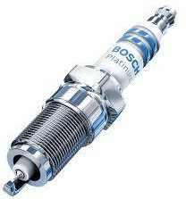

#### Function of the spark plug

The main function is to introduce the ignition energy into the combustion chamber and to initiate the combustion of air fuel mixture through the electrical spark between its electrodes.

It must permit reliable cold starting. It must guarantee that there is no misfiring during acceleration and it must withstand the engine being operated for hour on and at maximum power.

These requirements apply throughout the entire service life of the spark plug.

#### Parts of Spark Plug

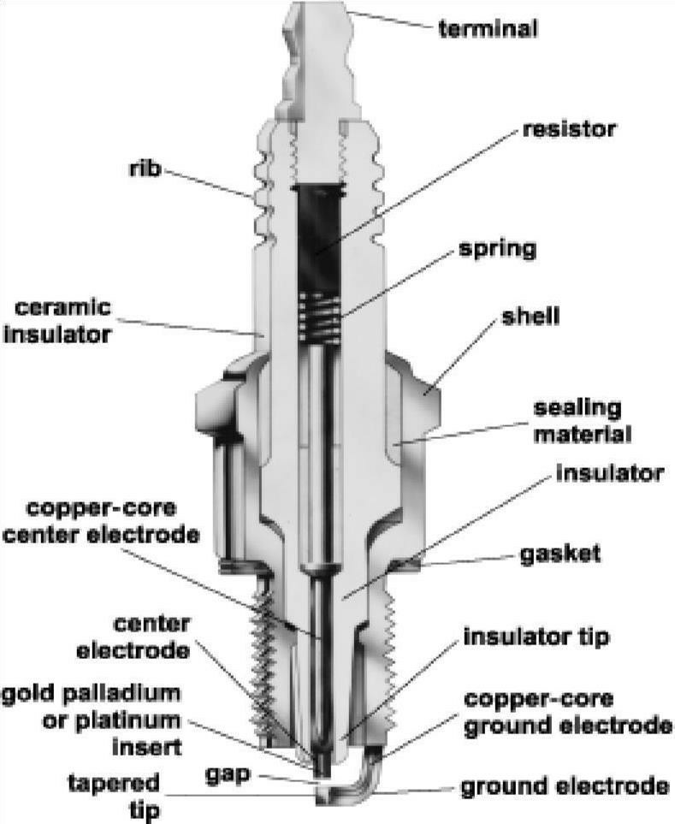

##### Terminal Stud(KBO)

The terminal stud or KBO is fused into the insulator with a special conductive seal whose main purpose is the electrical connection to the Centre Electrode (KEL). The terminal stud connects the spark plug to the Ignition System.

##### Insulator

The insulator is a very hard ceramic material with a dense microstructure which has high dielectric strength.

Its major function is to provide mechanical support and Electrical and Thermal insulation for the central electrode.

##### Ribs

The physical shape of the ribs functions to improve the electrical insulation and prevent electrical energy from leaking along the insulator surface from the terminal to the metal case.

##### Insulator tip(foot)

Insulator tip is the part of the insulator protruding into the combustion chamber.

##### Housing

The insulator housing is made up of mild steel and is coated with a layer of Nickel to prevent from corrosion. The function of spark plug Housing is

* + It serves in removing heat from the insulator and passes it to the cylinder head.
  + It acts as the Ground for the sparks passing through the Centre electrode to the ground electrode. It secures the insulator in the cylinder head.

##### Center Electrode

The center electrode is connected to the terminal through an internal wire and commonly a ceramic series of resistance to reduce emission of RF noise from the sparking. Non-resistor spark plugs, commonly sold without an "R" in the plug type part number, lack this element to reduce electro-magnetic interference with radios and other sensitive equipment.

On Bosch Spark plugs, the Center electrode is made of wear resistant nickel alloy with copper core. The copper core has high thermal conductivity.

Modern engines operate at particularly high combustion temperatures. This places strain on the spark plugs, and increases the wear on electrodes. To compensate for this, precious metal alloys using Platinum, Iridium or Silver is used.

##### Ground Electrode

The Ground electrode also known as the "Earth Electrode" is made from high nickel steel and is Resistance to the side of the metal shell. The Ground electrode also runs very hot, especially on projected nose plugs. Some designs have provided a copper core to this electrode, so as to increase heat conduction. Multiple ground electrodes may also be used, so that they don't overlap the central electrode.

##### Electrode gap

The electrode gap is the shortest distance between Centre electrode and Earth electrode. It is the measure of the length of the ignition spark. The smaller the electrode gap, lower the ignition voltage required.

If the electrode gap is too small, voltage required is less, but misfiring may occur because the spark gap is not readily accessible to the mixture. If the electrode gap is too big, a high ignition voltage is required, although the mixture has good access to the spark gap. The electrode gap is usually in between 0.6 to 1.8mm (0.024 to 0.071 in).

**MANUFACTURING OF SPARK PLUG**

There are four main process involved in manufacturing process, they are:

1. Ceramic Insulator Manufacturing
2. Insulator Assembly
3. Housing and Final Assembly.

#### Insulator Manufacturing Process

Each and every part of spark plug is manufactured and assembled here at Naganathapura plant. More than 150 different types of

sparkplugs are manufactured here. Insulator is made of ceramic materials. The following are the steps involved in Insulator manufacturing.

➢ **Ball Milling:**

The raw material involved in the production of the insulator is a mixture of 4 different constituents. There are two types of mixture used, namely KM38 and KM39. These two differ in the composition of the constituents added.

The constituents of the raw material are: Calcite Alumina, China Clay, Talc and Calcite.

##### KM38

|  |  |  |  |
| --- | --- | --- | --- |
| Quality | Percentage (%) | Weight (kg) | Precision (kg) |
| Raw Materials |
| Calcite Alumina | 90.97 | 2184 | 20 |
| China Clay | 4.80 | 115 | 0.5 |
| Calcite | 3.55 | 85 | 0.5 |
| Talc | .68 | 16 | 0.5 |

**KM39**

|  |  |  |  |
| --- | --- | --- | --- |
| Quality | Percentage (%) | Weight (kg) | Precision (kg) |
| Raw Materials |
| Calcite Alumina | 90.47 | 2171.28 | 20 |
| China Clay | 5.59 | 134.16 | 0.5 |
| Calcite | 3.68 | 88.32 | 0.5 |
| Talc | .25 | 6.00 | 0.5 |

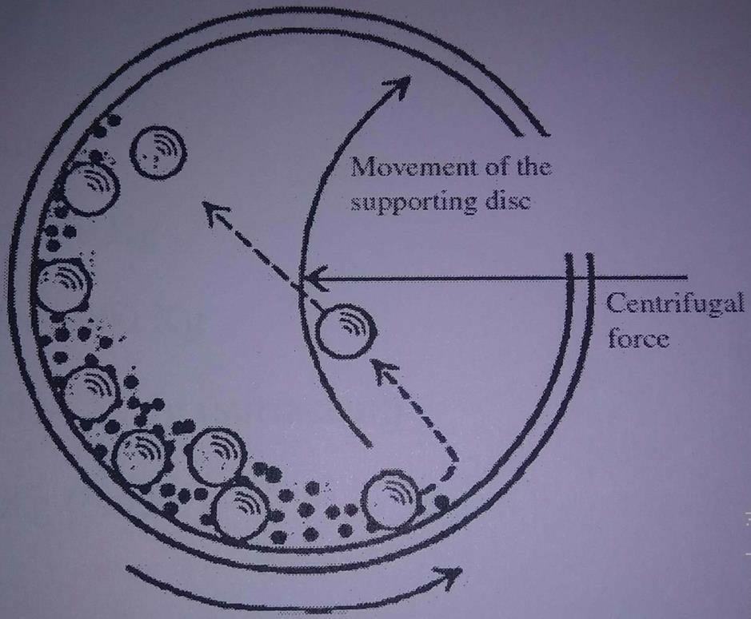

The mixed components are then loaded into the ball mill for 8 to 10 hours (10080 revolutions/8 hours). There are 4 types of ball mill with a diameter of 30mm, 40mm,50mm and 60mmwith a weight range of 1862+3kg, 1410+3kg, 1191+3kg and 657+1kg respectively.

The fresh milled material is then mixed with the recycled material which is obtained from the pieces broken in the further operations.

After the mixing the homogenous mixture is sent for quality checking by taking a sample of 200 to 300 grams. In the test the following results are expected:

|  |  |
| --- | --- |
| Press Density | 2.11 to 2.17 g/cm3 |
| Sintered Density | More than 3.72 g/cm3 |
| Bulk Density | 1.03 to 1.113 g/cm3 |
| Moisture Content | 0.4% |

#### Blunging:

This operation is carried out in a machine called BLUNGER. The blunging machine is an octagonal tank with a mixer. To carry out blunging operation, binding solution is required.

Preparation of binding solution:

The binding solution contains chemicals such as De-hypon which acts as a surfactant and Mow oil which is a Binder.

The binder solution is made by filling 80litres of water in heating drum and adding de-hypon of 20grams and also Mow oil of 20kgs. Then set the rotational speed at 800rpm and temperature at 85°C and the stirring time is set for 3hrs.

Blunging operation:

Add 350 kg of freshly milled material and 900 kg of recycled material from ball milling machine and add correct amount of binder solution and water and stirred for 3 hours with a temperature of 85+/-10*C.

##### Magnetic Separation:

The blunging slurry is fed into magnetic separator, where the magnetically susceptible particles are separated from the mixture using magnetic force. Before magnetic separation the slurry is allowed to flow in a Vibrator containing Sieve of gap 63 microns where all the non-magnetic particles are extracted.

##### Spray Drying:

It is a method of producing a dry powder from a liquid or slurry by rapidly drying with hot gas. It uses spray nozzle or atomizer to disperse the slurry into a controlled drop size spray. The pressure inside is about 250-10000 psi.

In this machine, hot air is fed from the air heater at inlet air of 345°C and the air that gets exhausted is of 140°C.

The slurry is then sprinkled throughout the atomizer by the sprinkler which is rotating at 1700-1800rpm. As the slurry moves along the atomizer all the moisture content is removed.

The ceramic particles are passed through the vibro sieve where the particle of homogeneous size is taken to the Niro Pulp container and the dust particles are separated in Niro pulp scrap container. The Nero Pulp in the form of powder is collected and sent to Iso-static Pressing.

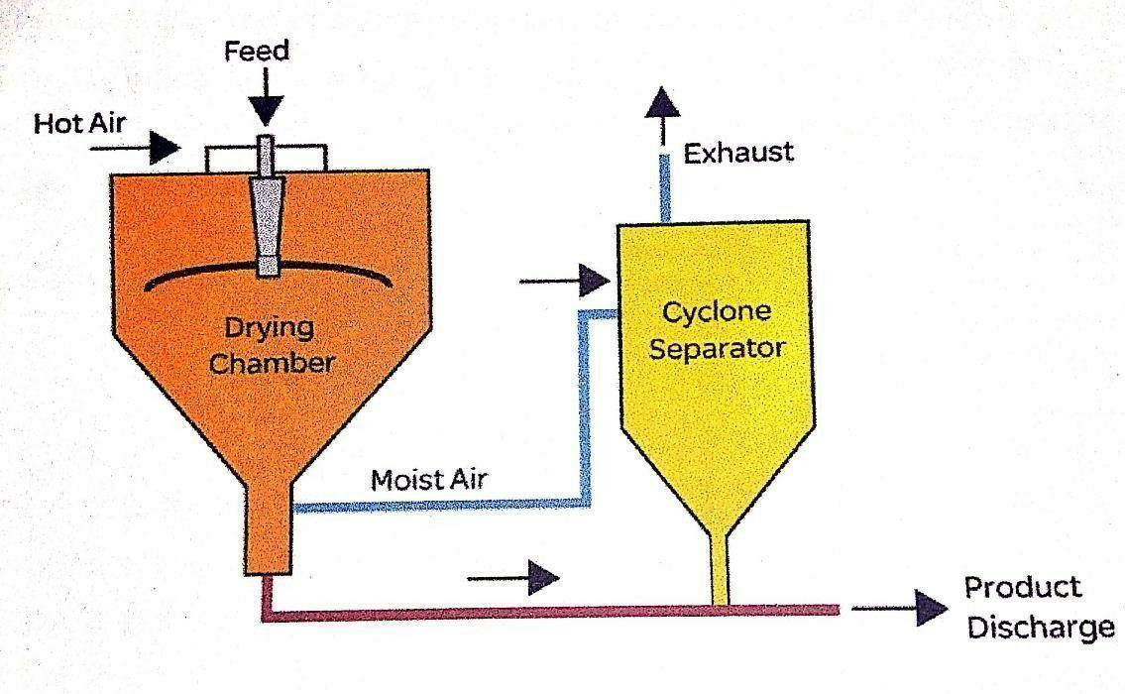

##### Iso-static Pressing:

This process is mainly used to reduce the porosity and increase the density of the materials.

In Iso-static pressing the homogeneous ceramic particles are fed to the rubber bag which has the mould of the insulator in it. The rubber bag is then pressed uniformly all over and the insulator shape is made.

The uniform pressure of around 300-400 bars is applied on it in all directions so that the powder gets basic shape of insulator.

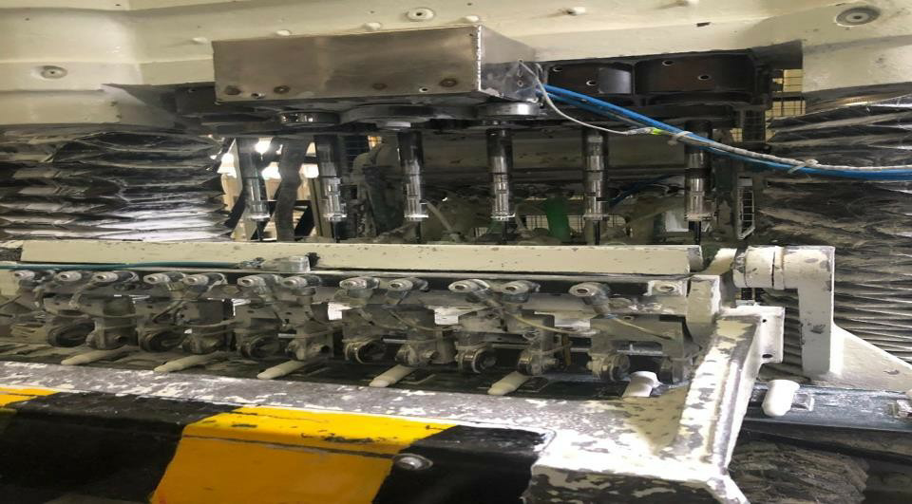

Iso-static Pressing

##### Profile Grinding:

The soft insulator is fed to the grinding machine where the perfect shape of the insulator is made. The grinding wheel runs at 800 rpm. This grinding wheel in turn rotates the wheel which holds 48 mandrels. Each mandrel carries soft insulator and grinds the profile to required shape. Then the soft insulators are inspected visually for breakages pores and cracks and the damaged are sent for recycling.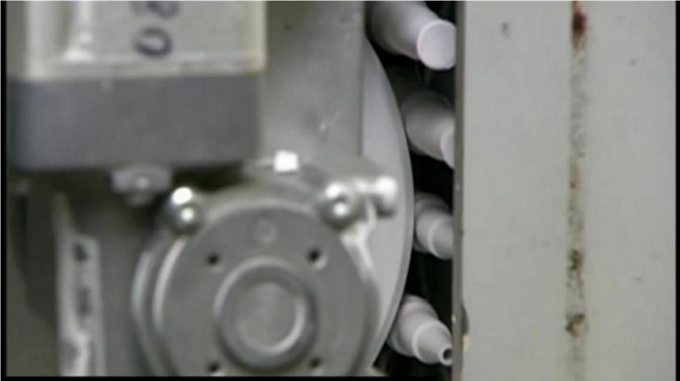

Profile grinding The grinding wheels are of two types:

* 1. **Diamond lapped:** Has a long life but once worn out, it cannot be redressed. The life of a grinding wheel is measured in terms of the number of insulators which are profile grinded.

The life of the diamond wheel is different for different profiles.

U, V, Y long type: 400000-600000 insulators

U, F, X, Y, short type: 1000000-1200000 insulators

W, M short type: 1000000-1200000 insulators W long type: 800000-1000000 insulators

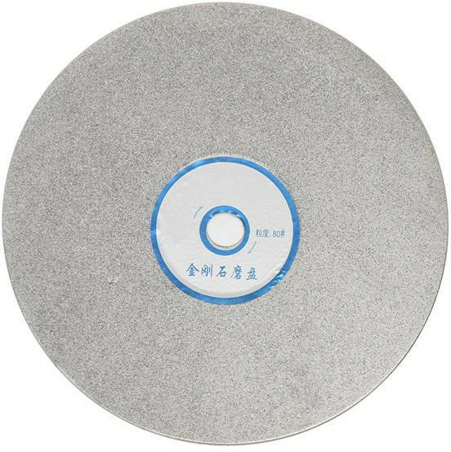

Diamond lapped grinding wheel

**Resin Bonded:** Has a very short life but can be redressed according to the requirement.

It has a life of approximately 35000 insulators.

The following parameters are checked after profile grinding

* + - Soft density
    - Outside profile
    - Head, foot and body cracks
    - Gasket diameter and head diameter
    - Collar diameter
    - Total length and Seat length

##### Density and Profile inspection:

The profile of the soft insulator is verified with the help of profile projector.

The density of the insulator is also checked. The required density of a soft insulator is **2.13-2.18g/cc**.

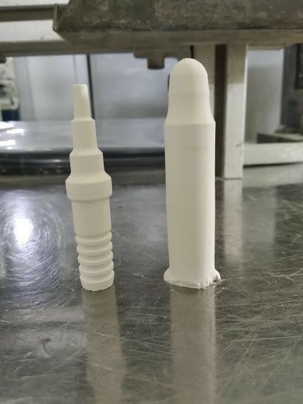

Soft Insulator (Before and after Grinding)

##### Sintering:

Sintering is the process of compacting and forming a solid mass of material by heat or pressure without melting it to the point of liquefaction.

The soft insulator is kept in sager boxes made of ceramic material and fed into the furnace. There are three stages in furnace, Preheating zone, hot zone and cooling Zone. The fuel used is piped natural gas (PNG). In pre-heating zone, the temperature is maintained at 1400°C and the temperature is linearly increasing till 1600°C in the hot zone, where the temperature is maintained constant. Each cycle time for one trolley is 90 minutes. This time is called as soaking time. The total hours of the process are is around 28hrs.

This process also reduces the porosity of the material and it results in shrinkage in the size of the insulator. The hard insulator is smaller in size than the soft insulator. Shrinkage in length: 22- 23% Shrinkage in diameter:21-22%

Example:

Type**- UR4AC**

|  |  |  |
| --- | --- | --- |
| Diameter of | Soft Dimensions(mm) | Hard dimensions(mm) |
| Gasket | 7.62 | 6.34 |
| Collar | 15.13 | 12.51 |
| Head | 12.50 | 10.40 |

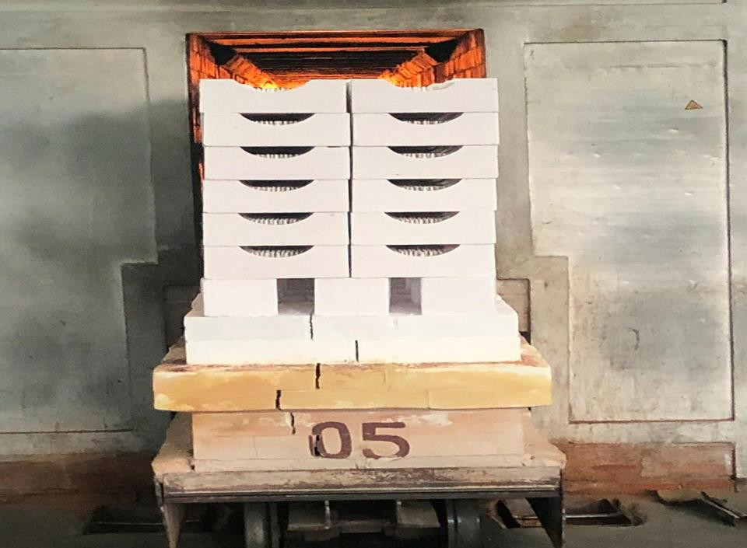

Sintering Process

##### Density and profile inspection of the hard insulator:

The density of the hard insulator is inspected. The value should be greater than or equal to 3.67 g/cc.

Also, the density of the foot must be greater than the density of collar and head.

If the density of the insulator is less than the required value, it must be re-fired.

The profile of the insulator is also inspected with the help of profile projector. If the profile is not OK, then that piece is considered as scrap.

##### Visual inspection:

In visual inspection, the baked insulator is manually inspected as well as automated. Here the operator uses the 4X magnification lens to inspect the insulator.

Normally appearing defects are: Damages and cracks on head and foot, grinding defects, material deposits and inclusions, ovality in bore, collar damage, bending of foot nose.

##### Electrical crack testing- Backlight equipment

In this process the insulator is inspected for electrical conductance through it. Before testing for any crack, the insulator is first checked for any bends by making it go through a mandrel.

**Crack test**: The insulator is inserted into a mandrel and an electric arc of 25000 volts is projected on the insulator for 5 to 6 seconds.

**OK**: Sparking on surface and passing above nose tip.

**NOT OK:** Sparking through the insulator at the place of cracks.

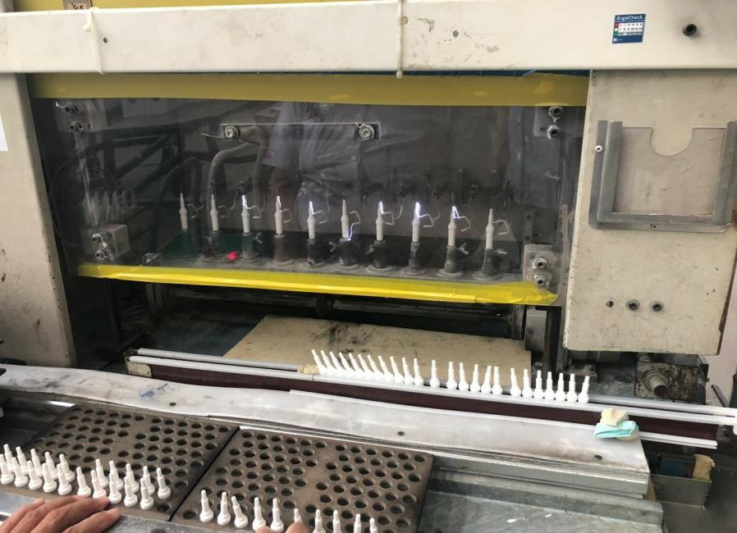

Cracked Testing

##### Final product:

After all these above steps the final insulator is obtained which can be sent for assembling process.

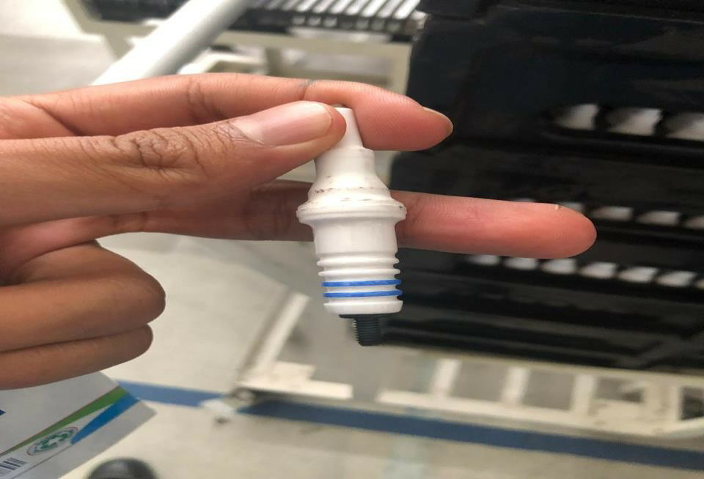

**CENTER ELECTRODE (KEL) MANUFACTURING**

* + **Button Heading:**

In this process, copper and nickel wire are wounded on the roller and this wire will be pulled in by the button heading machine. This wire is punched so that it obtains cylindrical shape (button).

Nickel button will be having a diameter of 6/7/8 mm and height of 2.5/2.25/2 mm.

Copper button will be having a diameter of 6mm and a height of 3 mm.

#### Button Welding:

Both copper and nickel buttons are welded together by resistance welding machine.

Firstly, nickel button is placed in the slot and then copper button is placed over it and then it’s welded.

At a time 3000 buttons are charged to this machine.

#### KEL Heading:

The welded buttons are then fed into an extrusion machine where it is extruded in the form a screw but without threads.

Now this is fed into the heading machine and the top portion is chopped off and then it is pressed to obtain a bimetal centre electrode.

#### KEL Inspection:

KEL is to be inspected visually by the use of 40X magnification lens. Visual inspection is done for the following defects

* + - Damages on shaft surface.
    - Damages on collar.
    - Damages on ribbing.
    - Copper present outside
    - Undergrounded/taper on shaft tip surface

Some defects are checked using some gauges. The defects are

* + - Throttle height
    - Flute diameter and length
    - Step diameter and length
    - Shaft length and diameter
    - Collar thickness and diameter
    - Collar/flute run out

## INSULATOR ASSEMBLY MANUFACTURING

* **Inscription Rolling and Ring Rolling:** Inscription Rolling is the process of producing the name of the manufacturing company on the insulator.

Ring Rolling is done by the use of two rollers: one driven and one idle, acting on either side of the insulator’s cross section.

Blue color pigment is coated on the leakage current barriers.

#### Glazing:

Pink color glaze is applied on the insulator. This is applied by two rollers, first with more depth rollers and then with less depth which acts as finishing roller.

This process is to coat a ceramic body with a vitreous substance. Glaze may serve function of glazing is:

* + It seals the inherent porosity.
  + It also gives a tougher surface.

Glazing is done on collar region of the insulator. This process is carried out at a temperature of about 350 degree Celsius.

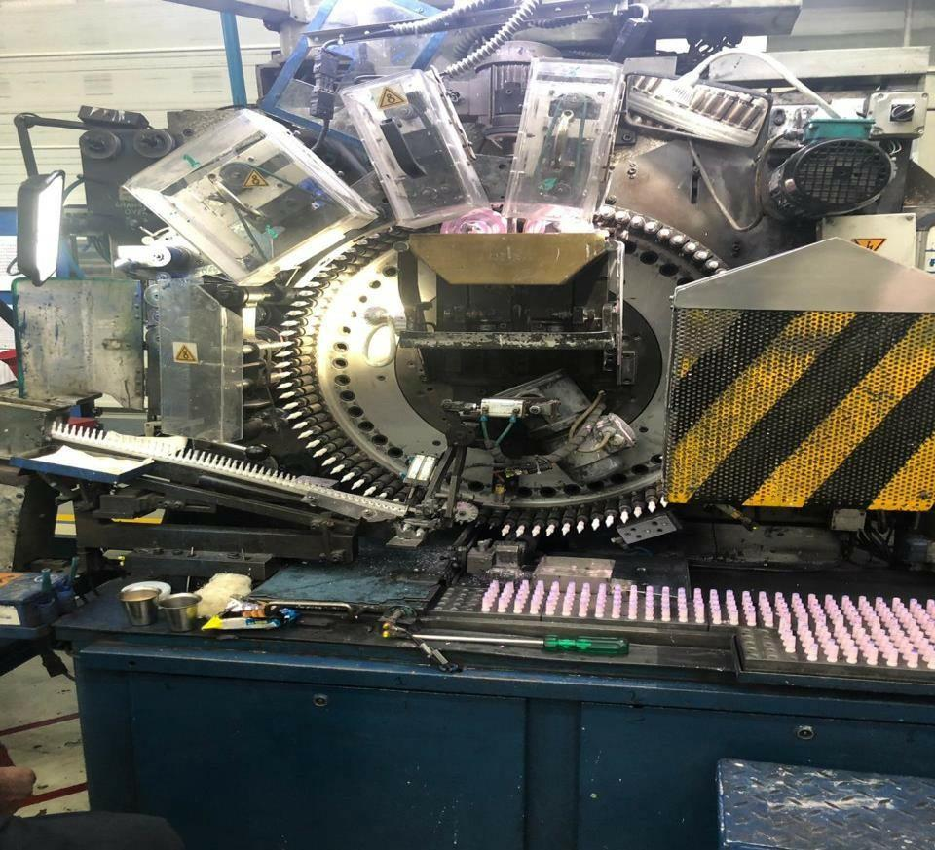

Inscription, Ring rolling, Glazing

#### KEL Feeding:

After glazing, the insulator is fed with the centre electrode also called as KEL. After feeding KEL, Poka-Yoke is done which checks the presence of KEL inside the insulator. If the insulator is absent, the

process stops and the KEL is fed manually.

#### Panat Feeding:

Contact panat and resistor panat are fed to the insulator i.e., on top of the KEL. Then this panat powder is pressed so that it is compact.

Panat dosage is as follows

##### Type: WR8DC EMI

|  |  |  |  |  |  |  |
| --- | --- | --- | --- | --- | --- | --- |
| **Station** | 1st | 2nd | 3rd | 4th | 5th | 6th |
| **Panat** | Contact | Resistor | Resistor | Contact | Contact | Contact |
| **Volume (mm3)** | 190 | 345 | 325 | 200 | 80 | 75 |

**Packet Height**: 21.85mm

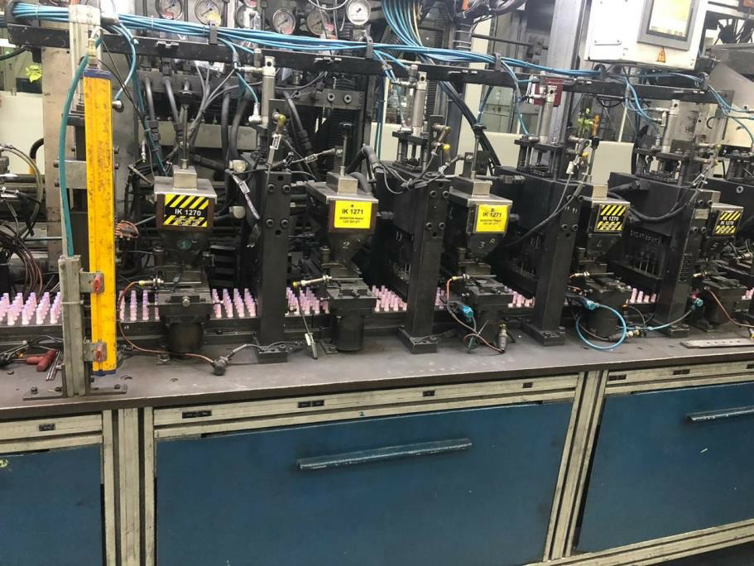

Panat Feeding

##### Pressure in Pressure stations:

|  |  |  |  |  |  |  |
| --- | --- | --- | --- | --- | --- | --- |
| **Station** | 1st | 2nd | 3rd | 4th | 5th | KBO |
| **Pressure in bar** | 68 | 68 | 68 | 68 | 68 | 50 |

* **KBO feeding:**

KBO is a terminal rod which is inserted into the insulator i.e., on top of the Panat. All these 3 feeding operations are carried out in a single machine.

After feeding KBO, Poka-Yoke is done which senses the presence of KBO.

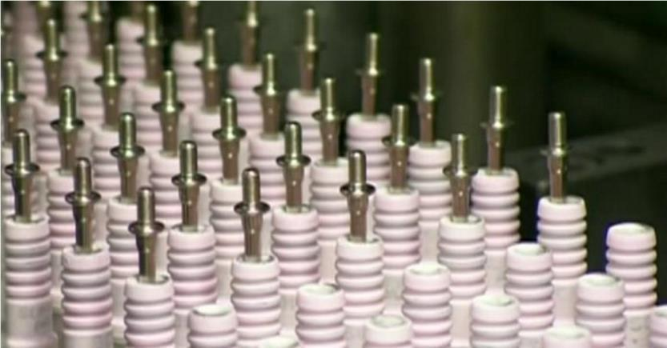

KBO feeding

#### Fusing:

The obtained assembly after KBO feeding is placed in a fusing plate and then heated in a heating furnace.

The furnace has 4 zones. Zone 1, zone 2, zone 3 and zone 4 have a

temperature of 620, 820, 869 and 865 degree Celsius respectively.

The assembly is pressed at a force of about 800+/-200N with 6mm deflection. This fuses the KBO into the insulator.

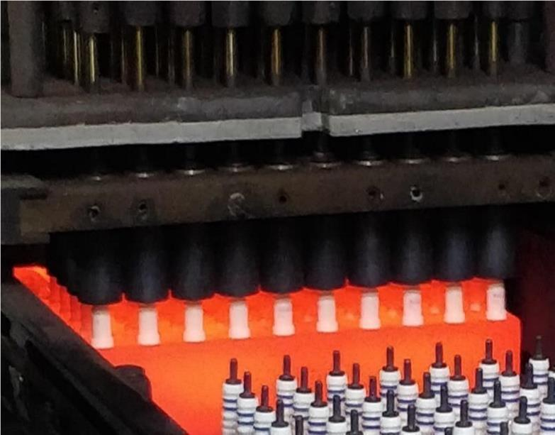

KBO Fusing

#### Resistance checking and Unloading:

The resistance of each insulator is checked. 5 insulators at a time will be checked for its resistance in multi-meter.

The multi-meter is set for lower resistance of 3 kilo-ohm and high resistance of 9 kilo-ohm. After the resistance checking, the insulator assembly is unloaded for visual inspection.

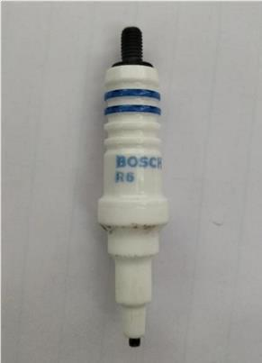

Final Product of Insulator Assembly

##### Visual inspection:

After resistance checking, the assembled product is checked visually for any damages on it. The inspection is carried out in a 4X magnification lens.

The pieces in which damages are found are put into scrap.

##### Acceptance test for fused Insulator

After the insulator assembly is done, some insulators are taken and the following parameters are checked

* **Sectioning of insulator:** Sectioning is done to check the following parameters:

1. Central electrode and the terminal bolt are cornered around perfectly.
2. Fusing shall be hard, glossy and cavity free.
3. Proper adherence of fused material to insulator bore.

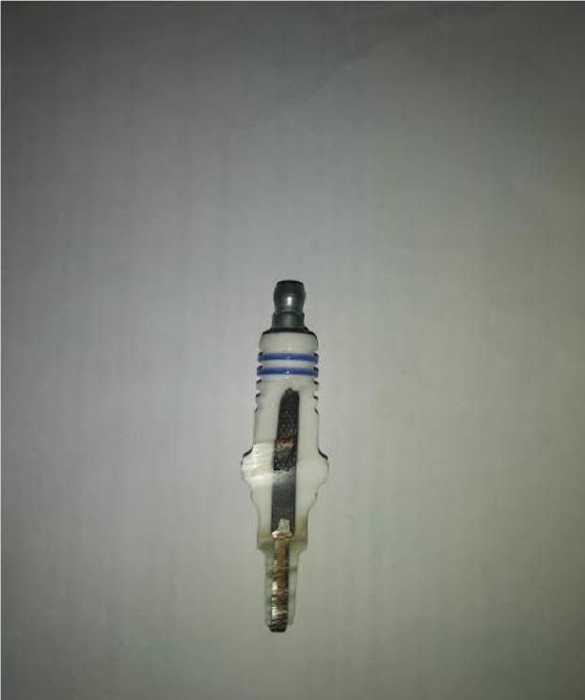

Sectioned view of the Insulator Assembly

* **Panat length:** The following lengths are verified

1. Lower contact packet: Minimum distance between centre electrode and resistor panat.
2. Length of resistor panat.
3. Length of upper contact packet: Minimum distance between resistance packet and KBO shaft. **4.** Total length of packet length
4. Upper contact packet along spark axis

We can check the interior dimensions of the fused insulator either through

* 1. Sectioning the fused Insulator
  2. By checking out the insulator profile through profile projector.
* **Pull-out strength of KBO:** The strength required to pull out the KBO bolt out of fused insulator.

Minimum 2500N for all W types.

Minimum 2500N for all X, XR, VR, Y and YR types. Minimum 1500N for all U, UR types.

#### HOUSING MANUFACTURING PROCESS

##### Turning Operation:

The slugs are obtained from casting. These slugs are not produced in this plant.

These slugs are then turned for required dimensions in a CNC machine. To operate a single part, it takes about 3 seconds. Totally 8 operations are carried out.

The following dimensions to be checked after turning operation are;

* + - Seat to Rim length
    - Shaft length
    - Thread reach
    - Seat to gasket face
    - Sinker depth or foot bore depth
    - Seat to earth electrode face
    - Hexagon height
    - Front seat height
    - Undercut diameter
    - Hot curl diameter
    - Foot bore diameter
    - Foot step diameter
    - Thread blank diameter

##### Tumbling Operation:

This process is used to burnish, de burr, clean, de-scale, remove rust, surface harden, brighten, polish, and break off die cast runners.

The machine has a horizontal barrel, filled with the parts which are then rotated. The process also requires lubricants and water.

##### Cleaning:

This is the process of cleaning the housing parts so that it doesn’t contain any oil or lubricants which was used in previous processes. Cleaning of the housing parts is done using a cleansing agent known as UNISOLE-NE.

##### Earth Electrode Welding:

It is the process of welding Earth electrode to the bottom of housing. The type of welding used here is resistance welding.

Basically, Nickel wire is used for the ground electrode. The main parameters in this process are; temperature and pressure. Actually, this step is carried out in 3 steps;

* + - Earth Electrode welding
* Broaching of the inside welding pip.
* De burring of the outside welding pip.

In the next step which is carried out in the same machine, Poka-Yoke is done which inspects whether the earth electrode is properly welded or not. If it’s not welded proper, there will be sensors to detect it and will send the piece back for re-welding. Based on the spark plug applications, there may be one, two, three or four earth electrodes.

After this process, 5 out of 2000 pieces are checked for the dimensions of inside pip, outside pip, resistance and also the gap between component and welding jaws. Weld current is 2.1KA with a tolerance of 0.1 KA.

The value of resistance should be more than 0.1 mega ohm.

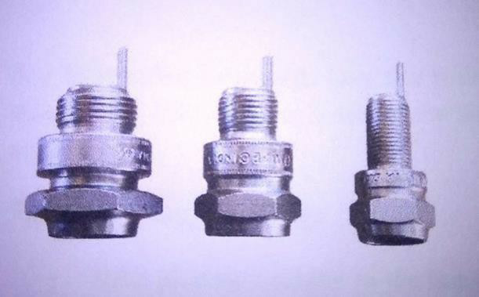

##### Thread Rolling and Inscription Rolling:

Thread rolling process is used to form threads on the housing for screwing in the cylinder head.

The machine used is Thread rolling machine. The machine houses a roller which rotates with a speed of 900 rpm. Hydraulic pressure of 20+/-10 kg/centimeter square is applied on the rolls to obtain the thread. Time taken for threading one housing is around 0.64 seconds.

Inscription Rolling is the process of putting the name of manufacturing company as well as the type of spark plug on the housing.

|  |  |  |
| --- | --- | --- |
| Type | Hydraulic Pressure (Kg/cm2) | Rolling Time (millisecond) |
| U - Short | 6.5 | 20+5 |
| U - Long | 9 | 25+3 |
| M | 11.5 | 20+5 |

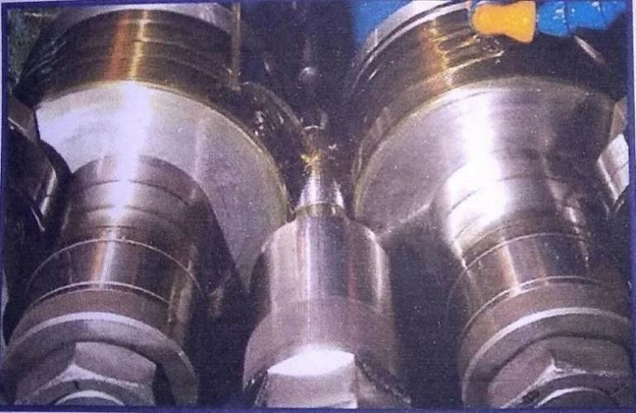

Thread Rolling Process

#### Nickel Plating:

It is the process of coating the housing part with Nickel. Parts to be electroplated must be free from dirt, corrosion and defects before the process begins. The part should be properly cleaned before using it for electroplating. It is done by the combination of processes called heat treatment, cleaning, masking, pickling and etching.

After cleaning the part properly, it should be immersed in an electrolyte solution and this housing part here acts as cathode. The Nickel anode is dissolved in the electrolytic solution to form nickel ions. The ions from the solution get deposited on the housing part.

The main purpose of doing electroplating is, it improves the resistance to corrosion.

This process is not carried out in Bosch and are outsourced.

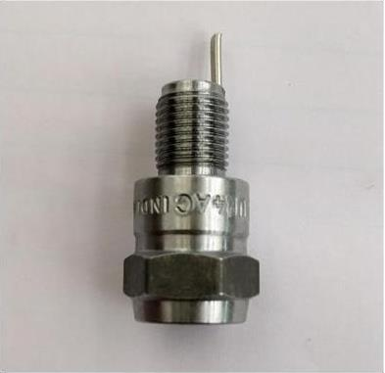

#### Housing (Final Product)

**Final Product:**

After all the above processes, the final product is obtained which can be sent for final assembling process.

## SPARK PLUG FINAL ASSEMBLY PROCESS

##### Housing Loading:

The nickel-plated housings are fed to the auto assembly machine. It is sensed for proper placement on the machine.

##### Rim Oiling:

After loading the auto assembly with the housings, the rim of the housing is oiled to ensure that there will be no resistance while assembling further.

##### Bottom Washer Loading:

Copper plated washer is fed to the housing, such that the convex surface of the washer makes a seat on the housing.

##### Insulator Loading:

Insulator is inserted into the housing which contains the copper plated washer in it. There will be a sensor to sense the presence of insulator in the housing and then sent to the next station.

##### Top Sealing Ring Loading:

After placing insulator in the housing, top sealing ring is inserted. This ring seats above the copper washer but it does not come in contact with it. Poka-Yoke is done to check the presence of sealing washer and KBO bend.

##### Top Ring Oiling:

After inserting the top ring in the assembly, it is oiled to ensure good lubrication. Good lubrication reduces the friction.

##### Pre-Curling:

In this process, the top of the housing is pressed at high load such that it makes the insulator assembly, washer and ring are intact without any movement.

It also reduces the thickness of the sealing washers lightly.

Until this process, the spark plug assembly will be loosely placed. The pre-curling load varies from 2.2 to 4.2 tons. The Sealing washer thickness after Pre Curling ranges from 0.2 to 0.54mm. All these factors depend upon the type of Spark Plug manufactured.

##### Hot curling:

This process is done in order to ensure gas tightness in the spark plug assembly. Shrink zone is generated in this process which guarantees gas tightness.

In this process, the spark plug assembly is pressed at a lower force compared to the pre-curling process, but at high temperature.

The hot curling load varies from 1.2 to 2.4 tons.

This process is carried at a temperature of around 1000 degree Celsius. After hot curling, Poka-Yoke is done in the form of online electrical crack test which checks for the cracks on the insulator assembly.

##### T-Nut Screwing:

In this process, a terminal nut is inserted. This nut is not mandatory to put. It depends on the customer requirements.

##### Shearing of Earth Electrode:

In this process, the earth electrode is cut off for the required length based on the type of spark plug.

##### Bending of Earth Electrode:

It is the process of bending the earth electrode towards the centre electrode. Correct gap should be maintained between the earth electrode and the centre electrode i.e., the machine should be properly calibrated for that particular value.

##### Insertion of Washer and Pressing:

In this process, non-fall able washer is inserted to the assembly and pressed to form a ring shape. This washer is to free to move over the housing.

##### Auto Unloading:

After inserting non-fall able washer and terminal nut, the spark plugs are unloaded automatically and are arranged in a tray which is sent for visual inspection.

##### Visual Inspection:

The various parameters checked here are;

* Housing defects
* Earth Electrode damage, burr
* Housing thread damage
* Centre electrode damage, bent, peeling off
* Insulator nose glazed
* KBO bent/damaged/collar projection
* Foot face damage

##### Final Product:

Completely assembled Sparkplug is ready and is sent to testing.

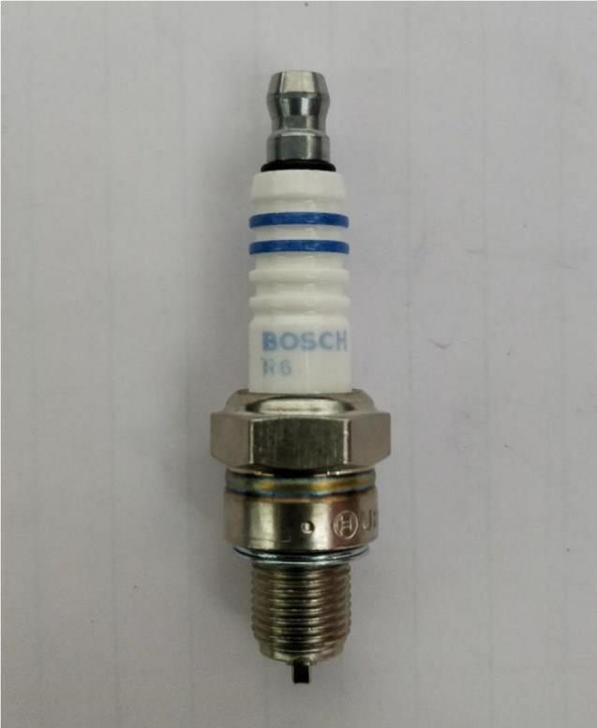

Final Product

## Requirements of a Spark Plug

##### Mechanical Requirements:

* + - Pressure tight and gas tight sealing of the combustion chamber, resistance to oscillating pressures up to100bar.
    - High mechanical strength for reliable installation.

##### Thermal Requirements:

* + - Resistance to thermal shock (hot exhaust gas, cold mixture intake)
    - Good thermal conduction by insulator tip and electrodes.
  + **Electrical requirements:** Reliable high- voltage transmission, even at ignition voltages of up to 40000volts.
  + **Electrochemical Requirements:** Resistance to spark erosion, combustion gases and residues.

## Parameters affecting the Function of Spark Plug

##### Spark plug Gap

Spark Plugs are typically designed to have a spark gap which can be adjusted by the technician installing the spark plug, by bending the ground electrode to the required amounts. The gap adjustments can be crucial for proper engine performance. A narrow gap may give a weak spark which cannot effective ignite the air-fuel mixture, but the plug will almost always fire on each cycle. A wide gap may prevent the spark from firing at all, or may misfire at high speeds, but ensures a strong spark whenever it ignites.

##### Heat range

It is important to choose the right heat range for the spark plug and to make sure that the spark plug operates at the temperature range between 500-900-degree Celsius. Pre ignition is prevented in this range. In addition to this, oxidation and hot gas erosion is reduced decreasing electrode wear.

## 5s Principles



### 1.Sort/ Seiri

The first step of 5S, Sort, involves going through all the tools, furniture, materials, equipment, etc. in a work area to determine what needs to be present and what can be removed. Some questions to ask during this phase include:

1.What is the purpose of this item? 2.When was this item last used?

3.How frequently is it used? 4.Who uses it?

5.Does it really need to be here?

These questions help determine the value of each item. A workspace might be better off without unnecessary items or items used infrequently. These things can get in the way or take up space. Keep in mind the best people to assess the

items in a space are the people who work in that space. They are the ones who can answer the above questions.

When a group has determined that some items aren't necessary, consider the following options:

1.Give the items to a different department. 2.Recycle/throw away/sell the items.

3.Put items into storage.

### 2.Set in order/ Seiton

Once the extra clutter is gone, it's easier to see what's what. Now work groups can come up with their own strategies for sorting through the remaining items. Things to consider:

1.Which people (or workstations) use which items? 2.When are items used?

3.Which items are used most frequently? 4.Should items be grouped by type?

1. Where would it be most logical to place items?
   1. Would some placements be more ergonomic for workers than others? ii)Would some placements cut down on unnecessary motion?
2. Are more storage containers necessary to keep things organized?

During this phase, everyone should determine what arrangements are most logical. That will require thinking through tasks, the frequency of those tasks, the paths people take through the space, etc.

### Shine/Seiso

Everyone thinks they know what housekeeping is, but it's one of the easiest things to overlook, especially when work gets busy. The Shine stage of 5S

focuses on cleaning up the work area, which means sweeping, mopping, dusting, wiping down surfaces, putting tools and materials away, etc.

In addition to basic cleaning, Shine also involves performing regular maintenance on equipment and machinery. Planning for maintenance ahead of time means businesses can catch problems and prevent breakdowns. That means less wasted time and no loss of profits related to work stoppages.

Shining the workplace might not sound exciting, but it's important. And it shouldn't just be left up to the janitorial staff. In 5S, everyone takes responsibility for cleaning up their workspace, ideally on a daily basis. Doing so makes people take ownership of the space, which in the long run means people will be more invested in their work and in the company.

### Standardize/Seiketsu

Once the first three steps of 5S are completed, things should look pretty good. All the extra stuff is gone, everything is organized, spaces are cleaned, and equipment is in good working order.

The problem is, when 5S is new at a company, it's easy to clean and get organized…and then slowly let things slide back to the way they were. Standardize makes 5S different from the typical spring-cleaning project. Standardize systematizes everything that just happened and turns one-time efforts into habits. Standardize assigns regular tasks, creates schedules, and posts instructions so these activities become routines. It makes standard operating procedure for 5S so that orderliness doesn't fall by the wayside.

Depending on the workspace, a daily 5S checklist or a chart might be useful. A posted schedule indicating how frequently certain cleaning tasks must occur and who is responsible for them is another helpful tool.

Initially, people will probably need reminders about 5S. Small amounts of time may need to be set aside daily for 5S tasks. But over time, tasks will become routine and 5S organizing and cleaning will become a part of regular work.

### Sustain /Shitsuke

Once standard procedures for 5S are in place, businesses must perform the ongoing work of maintaining those procedures and updating them as necessary.

Sustain refers to the process of keeping 5S running smoothly, but also of keeping everyone in the organization involved. Managers need to participate, as do employees out on the manufacturing floor, in the warehouse, or in the office. Sustain is about making 5S a long-term program, not just an event or short-term project. Ideally, 5S becomes a part of an organization's culture. And when 5S is sustained over time, that's when businesses will start to notice continuous positive results.

**5 Maintenance Engineering.**

Maintenance Engineering is the discipline and profession of applying engineering concepts for the optimization of equipment, procedures, and departmental budgets to achieve better maintainability, reliability, and availability of equipment.

Maintenance, and hence maintenance engineering, is increasing in importance due to rising amounts of equipment, systems, machineries and infrastructure. Since the Industrial Revolution, devices, equipment, machinery and structures have grown increasingly complex, requiring a host of personnel, vocations and related systems needed to maintain them. A person practicing maintenance engineering is known as a maintenance engineer.

**Mechanical Maintenance**

A series of tasks performed at a frequency dictated by the passage of time, the amount of production, machine condition that either extend the life of an asset or detect that an asset had critical wear and is going to fail or break down constitute .

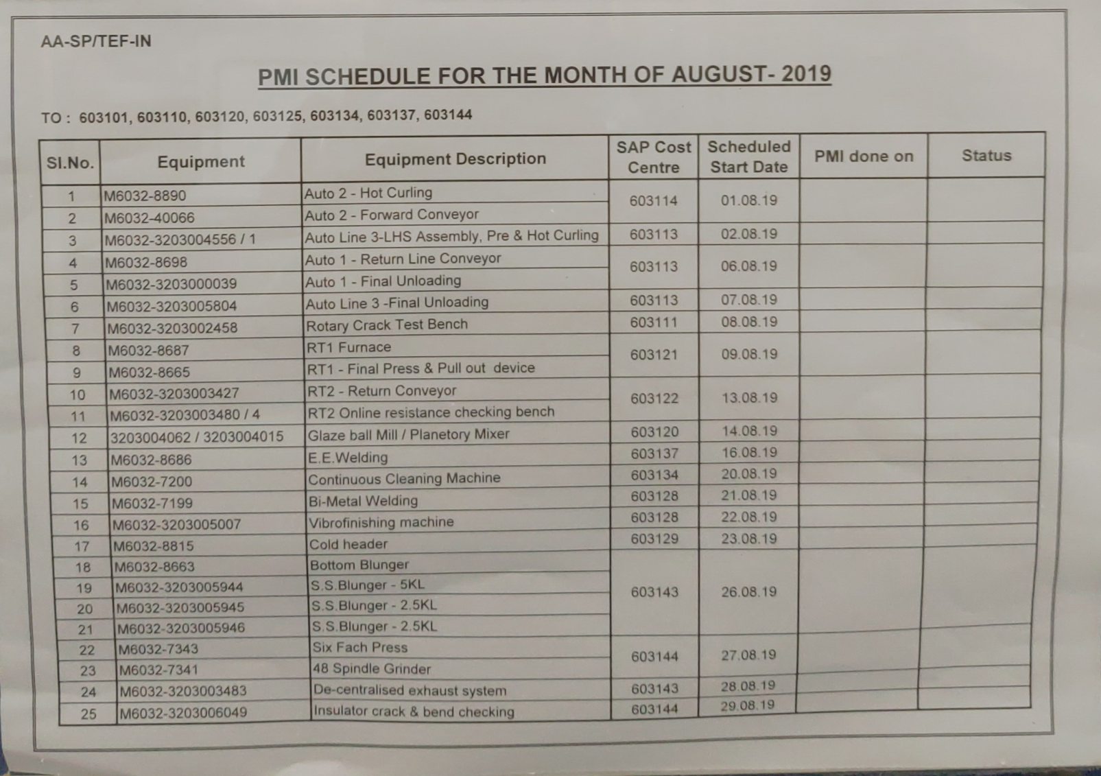

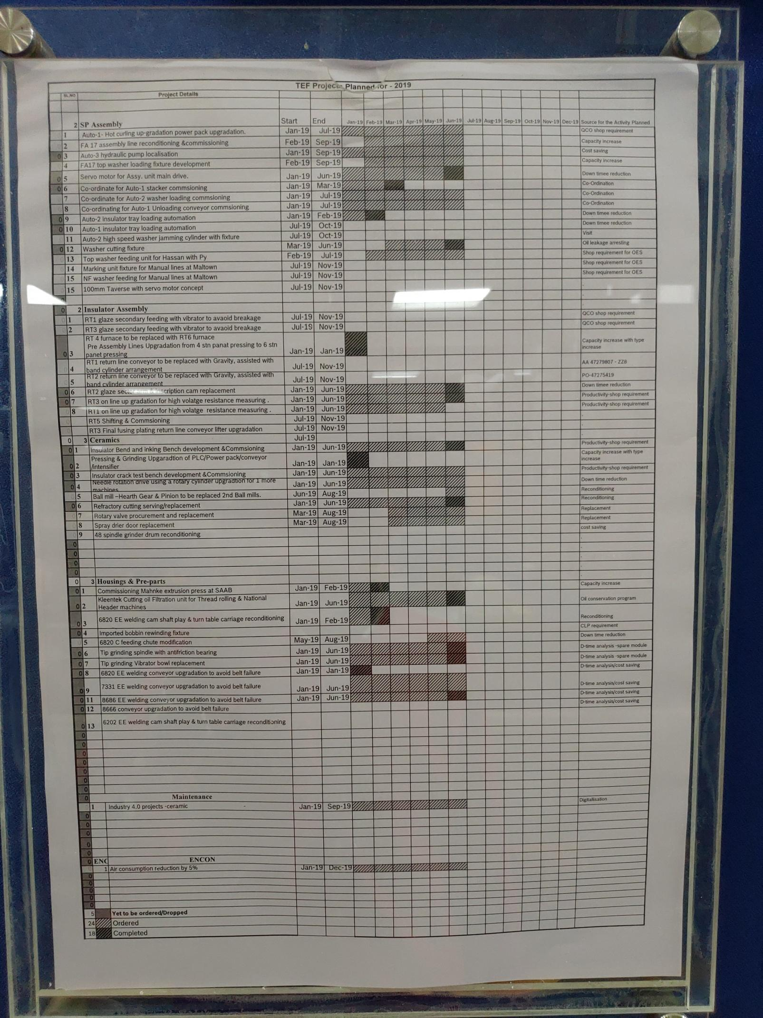

**Preventive mechanical Maintenance**

Preventive maintenance (or preventative maintenance) is maintenance that is regularly performed on a piece of equipment to lessen the likelihood of it failing. It is performed while the equipment is still working so that it does not break down unexpectedly. In terms of the complexity of this maintenance strategy, it falls between reactive (or run-to-failure) maintenance and predictive maintenance.

**Types of preventive maintenance**

Preventive maintenance can be scheduled on a time or usage based trigger. Let’s look at an example for each.

**Time-based preventive maintenance**

A typical example of a time-based preventive maintenance trigger is a regular inspection on a critical piece of equipment that would severely impact production in the event of a breakdown.

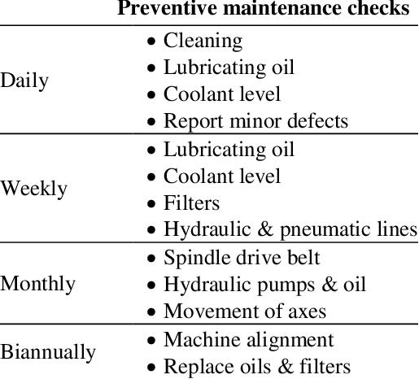

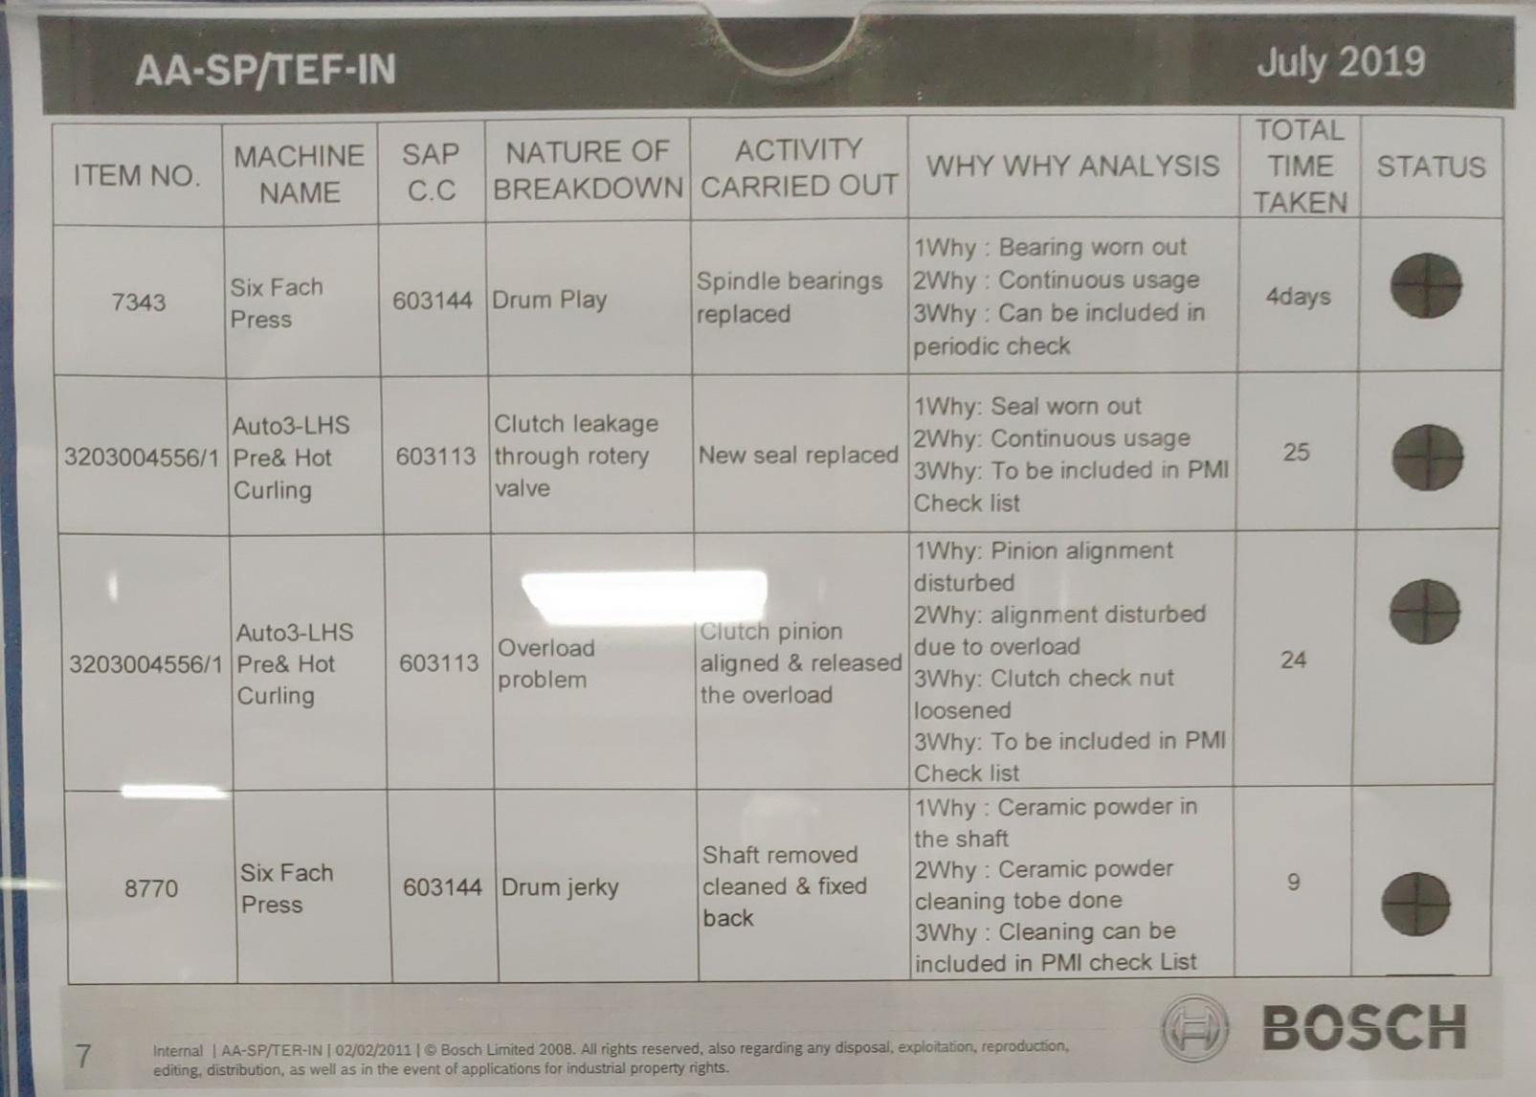

**Electrical maintenance**

Advances in the design and quality of electrical components have made it possible for electrical systems to run for years without noticeable problems. While wonderful feats of engineering, well-designed electrical systems can lull building owners and operators into a false sense of security—right up until the moment the system fails. It’s for this reason, among others, that electrical maintenance is such an important part of commercial building operations.

IT also covers all aspects of testing, monitoring, fixing, and replacing elements of an electrical system. Usually performed by a licensed professional with a complete knowledge of the National Electric Code and local regulations, electrical maintenance covers areas as diverse as:

– Digital communication

– Electrical machines

– Generators

– Hydraulics

– Lighting systems – Pneumatics

With an increased reliance on both data collection and machinery run by computer software, electrical maintenance is more vital than ever. The failure of a single component in the electrical system can cause extensive downtime or data loss.

**Preventative Electrical Maintenance**

Early identification of problems is a key aspect of electrical maintenance. For instance, should a back-up generator sit idle until needed, it may not start due to a number of factors. Old fuel clogging a fuel filter, uncharged starting batteries, or start switches left in the wrong mode can all prevent a smooth transition to backup power. These are basic problems, easily identified and addressed through preventative maintenance.

One of the major challenges to electrical maintenance is the nature of electrical wiring. It can be difficult to pinpoint the location of specific problems as the system is built into the building. Thermal imaging has become increasingly important in the industry for its ability to identify issues with both electrical connection points and equipment operation. By catching such problems early, electrical maintenance helps reduce unexpected power outages and protects equipment from damage.

**Hydraulic systems**

A hydraulic drive system is a quasi-hydrostatic drive or transmission system that uses pressurized hydraulic fluid to power hydraulic machinery. The term hydrostatic refers to the transfer of energy from pressure differences, not from the kinetic energy of the flow. A hydraulic drive system consists of three parts: The generator (e.g. a hydraulic pump), driven by an electric motor or a combustion engine or a windmill; valves, filters, piping etc. (to guide and control the system); and the actuator (e.g. a hydraulic motor or hydraulic cylinder) to drive the machinery.

**Hydraulic motor**

The hydraulic motor is the rotary counterpart of the hydraulic cylinder. Conceptually, a hydraulic motor should be interchangeable with the hydraulic pump, due to the fact it performs the opposite function. However, most hydraulic pumps cannot be used as hydraulic motors because they cannot be back driven.[citation needed] Also, a hydraulic motor is usually designed for the working pressure at both sides of the motor. Another difference is that a motor can be reversed by a reversing valve.

Pressure in a hydraulic system is like the voltage in an electrical system and fluid flow rate is the equivalent of current. The size and speed of the pump determines the flow rate, the load at the motor determines the pressure.

**Hydraulic valves**

These valves are usually very heavy duty to stand up to high pressures. Some special valves can control the direction of the flow of fluid and act as a control unit for a system.

Classification of hydraulic valves

Classification based on function:

• Pressure control valves (PC Valves)

• Flow control valves (FC Valves)

• Direction control valves (DC Valves)

Classification based on method of activation:

• Directly operated valve

• Pilot operated valve

• Manually operated valve

• Electrically actuated valve

**Hydraulic Intensifiers**

A **hydraulic intensifier** is a hydraulic machine for transforming hydraulic power at low pressure into a reduced volume at higher pressure

**TYPES**: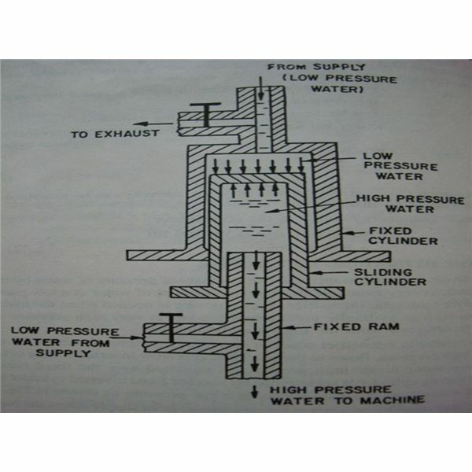

1.Single acting intensifier

2.Double acting intensifier

**Hydraulic Accumulator:**

A **hydraulic accumulator** is a pressure storage reservoir in which a non-compressible **hydraulic** fluid is held under pressure that is applied by an external source. The external source can be a spring, a raised weight, or a compressed gas.

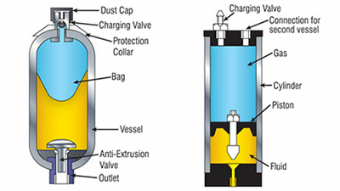

**Fast approach, slow feed and fast return mechanism :**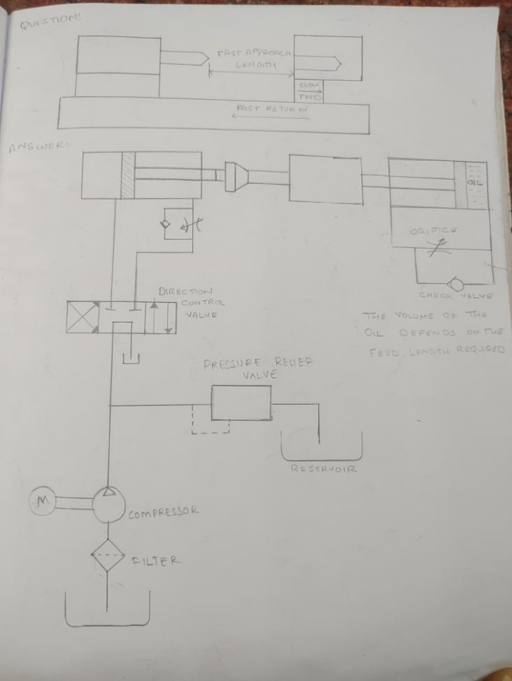

## Conclusion:

As we students of  **DAYANANDA SAGAR ACADEMY OF TECHNOLOGY AND MANAGEMENT**, we would like to say that this training program is an excellent opportunity for us to get to a ground level and experience the things that we would never gain through going straight into a job. We are grateful to BOSCH LTD, Naganathapura plant for giving us this wonderful opportunity. Overall internship is a really good program to enhance and develop the skills, abilities, knowledge.

The main objective of the industrial training is to provide an opportunity to undergraduates identify, observe and practice how engineering is applicable in real industry. It is not only to get experience on technical practices but also to observe management practices and to interact with fellow members.

Finally, we would like to thank each and every person who helped us directly and indirectly in learning period as everyone had co-operated with us and had the actual scenario of a manufacturing plant(spark plug).It was an amazing experience to get proficient and regulated at BOSCH LTD.